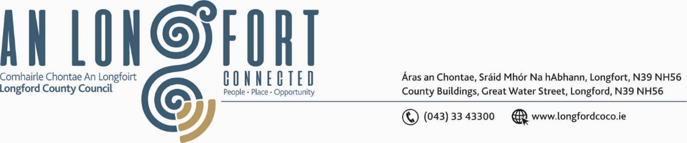

***BALLYMAHON MUNICIPAL DISTRICT***

***Please note meeting will be held on Microsoft Teams.***

**19th November 2021.**

**To: Each Member of Ballymahon Municipal District.**

**Dear Member,**

You are requested to attend a Meeting of Ballymahon Municipal District to be held

**on Microsoft Teams,** on **Thursday 25th November 2021 at 4pm** to transact business, as set out on the Agenda hereunder.

**Yours sincerely**,

Ann Marie Mc Keon

_______________

**Ann Marie Mc Keon,**

**Meetings Administrator.**

**AGENDA**

Prayer before meeting.

**1.** (i) Confirmation of Minutes of Ballymahon Municipal District Meeting held on

the 23rd September 2021 – copy enclosed.

(ii) Confirmation of Minutes of Ballymahon Municipal District Committee Meeting held on the 23rd September 2021 - copy enclosed.

(iii) Confirmation of Minutes of Ballymahon Municipal District Meeting held on the 28th October 2021 – copy enclosed.

(iv) Confirmation of Minutes of Ballymahon Municipal District Committee Meeting held on the 28th October 2021 – copy enclosed.

**2.** Matters arising from Minutes.

**3.** Declaration of Interest by Members.

**4.** Management Report - enclosed.

**5.** Item referred from the Placenames Sub Committee Meeting held on 12th October 2021 – Naming of Business Park on the Athlone Road, Ballymahon.

It was agreed that the Business Park on the Athlone Road, Ballymahon be named Castle Business Park - recommendation to be forwarded to Ballymahon Municipal District for consideration and approval.

**6.** Proposed Projects/Expression of interest – enclosed.

**7.** Consideration of applications for funding under the 2021 Community Grant Support

Scheme – enclosed.

**7. Notices of Motions, submitted by Councillors, as listed hereunder –**

**Councillor Paul Ross**

1. That flashing lights be installed at the approach to the new estate in Legan at Smithfield due to the speed of traffic into the village.
2. That Longford County Council apply for a low-cost safety scheme at the dangerous turn at Bawn, Moydow in which the boundary wall of a dwelling house has been hit 3 times in the last two years.
3. That Longford County Council formally take ownership of the Ardagh Clock Tower in order to allow the local committee to draw down grants to aid in the restoration of the tower and thus secure the long term future of this protected structure which is a key feature of county Longford’s architectural heritage.

**Councillor Gerard Farrell**

1. That Longford County Council roads department provide two additional street lights on the N63 Longford Road, Lanesboro.
2. “I call on Longford County Council Roads Department to erect a no overtaking sign on the N63 at the Derryad Junction”.
3. “I call on Longford County Council to review the junction between L5248-0 and L-5247-0 Gurteenboy and to carry out the necessary works to make this junction safer”.

**Councillor Mick Cahill**

“I call on Longford County Council to carry out improvement works on the Causeway to Saints Island”.